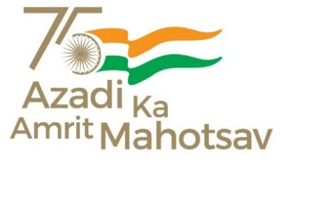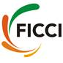

**“NEW FRONTIERS: A Programme on Renewable Energy”**

**Chintan Baithak on “****Roadmap to achieve net zero carbon emissions by 2070”**

**18 February 2022; 14:00 – 16:50 hrs, Virtual**

**Concept-Note**

**Background:**

The **Hon’ble Prime Minister of India** has laid out the country’s commitments for scaling up climate action at COP26 Summit in Glasgow in his **‘Panchamrit statement’** as a 5-point action agenda. The commitments include achieving Net-Zero by 2070**.**

This goal will require the government, industry and all the other stakeholders to work in tandem. In line with this vision and the fact that renewable energy sector has a critical role in this journey, **Ministry of New & Renewable Energy (MNRE)** and **Federation of Indian Chambers of Commerce and Industry** (FICCI) are jointly organizing the second edition of **Chintan Baithak** on February 18, 2022, from 14:00 to 16:50 hrs at a virtual platform.

The Baithak this year, will bring together State Governments, relevant Central Government departments, renewable energy industry and other key stakeholders together to brainstorm on India’s renewable energy roadmap for achieving the goal of net zero carbon emissions by 2070. The discussions will also highlight the imperatives and interventions needed to accelerate the deployment of renewable energy for achieving the targets set for us by the Hon’ble Prime Minister.

The first edition of the Baithak was organised in May 2019 with the objective to review the progress made in the renewable energy sector and obtain views of renewable energy industry CEOs and other stakeholders on key issues that industry was facing and for the future growth of the sector. The Chintan Baithak was intended to be a regular forum every year. However, since the pandemic hit in early 2020, the Baithak could not take place in last years.

**Objectives:**

Key objectives of the Chintan Baithak 2.0 will be as follows:

* Enable Indian policymakers and energy sector stakeholders to better understand key issues of renewable energy sector in line with net zero goals
* Discuss solutions and enablers for pathways for the energy transition and net zero targets
* Promote new areas of technology, innovative financing, and capacity building in the RE sector

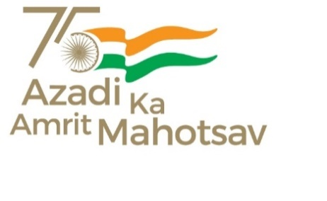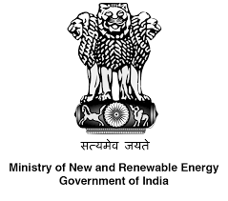

**Agenda**

|  |  |
| --- | --- |
| 14:00- 14:10 hrs | Welcome Address and setting the context by Mr Arun Chawla, Director General, FICCI |
| 14:10-14:30 hrs | **Keynote Address by Shri R.K. Singh, Hon’ble Cabinet Minister, Power & New and Renewable Energy, Government of India** |
| 14:30-14:45 hrs | Presentation by MoEFCC on Net Zero Carbon emissions by 2070 |
| 14:45- 16:50 hrs | **Session:**  A brainstorming session involving the MNRE, MOP, MOEFCC, Indian Railways, Principal Secretaries from leading renewable energy States, Public Sector Enterprises (BEE, NTPC, SECI, PGCIL etc.), Industry and other stakeholders (CEA, CERC, SERC etc.) to understand key issues of RE sector, Net Zero, solutions for future growth and pathways for energy transition and net zero targets. |
| 14:45 – 15:09 hrs | Presentations by State Government (8 mins each)   * Shri P. Ravi Kumar, Chief Secretary, Government of Karnataka * * Smt. Usha Sharma, Chief Secretary, Government of Rajasthan * * Shri Pankaj Kumar, Chief Secretary, Government of Gujarat * |
| 15:09 – 15: 17 hrs | Presentation by Shri B.K. Arya, Chairperson, Central Electricity Authority (CEA) * |
| 15:17 – 15:25 hrs | Presentation by Smt. Suman Sharma, Managing Director, Solar Energy Corporation of India (SECI) * |
| 15:25 – 16:05 hrs | Presentations by Industry   * Supply side issues and solutions   Presentation by Mr Shivanand Nimbargi Co-Chair, FICCI Renewable Energy CEOs Council and Chief Executive Officer, Ayana Power   * Demand side issue and solutions   Presentation by Mr Ranjit Gupta, Chair, FICCI Renewable Energy CEOs Council and Chief Executive Officer, Azure Power |
| 16:05- 16:45 hrs | Open House Discussion |
| 16:45 – 16:50 hrs | Concluding Remarks by FICCI |